NEW PATIENT INFORMATION FORM

NAME (Last, First, Middle): Title:
HOME ADDRESS:
PREFERRED NAME: SS NO: / / DOB: / /
HOME PHONE: ( ) - MARITAL: REF. DOCTOR:
WORK PHONE: ( ) - SEX: REF. PATIENT:
CELL PHONE: ( ) - EMAIL:
PREFERRED CONTACT FOR APPOINTMENT CONFIRMATIONS:
MEDICAL ALERTS:
PRIMARY DENTAL INSURANCE COVERAGE
SUBSCRIBER NAME: RELATION TO PATIENT:
SUBSCRIBER ADDRESS:
SS NO.: EMPLOYER:
PLAN / POLICY NAME: GROUP NO.:
INSURANCE COMPANY: IND YRLY DED:
ADDRESS: FAM YRLY DED:
SECONDARY DENTAL INSURANCE COVERAGE
SUBSCRIBER NAME: RELATION TO PATIENT:
SUBSCRIBER ADDRESS:
SS NO.: EMPLOYER:
PLAN / POLICY NAME: GROUP NO.:
INSURANCE COMPANY: IND YRLY DED:
ADDRESS: FAM YRLY DED:
RESPONSIBLE PARTY:
NAME AND ADDRESS:
SIGNATURE:

ACKNOWLEDGEMENT OF RECEIPT OF NOTICE OF PRIVACY PRACTICES
I , HAVE RECEIVED A COPY OF THIS OFFICE’S NOTICE OF PRIVACY PRACTICES.
DATE: SIGNATURE:

PATIENT RESPONSIBILITY
The patient is responsible for providing accurate and up-to-date information to the office of Dr. Todd W. Peters to provide care and insurance plan administrative services.
This information includes correct address, phone numbers, social security numbers, birthdates, insurance policy details and student eligibility forms.
In the event that we have not received correct and current information a $30.00 fee will be required to resubmit an insurance claim.
It is the patient’s responsibility to understand their insurance coverage. Any co-pays quoted by our office are only our best estimate of costs. The final word is always determined by the insurance company.
All appointments not cancelled with one business day’s notice will be charged a $25.00 fee.

Patient / Guardian Signature

Date

PATIENT MEDICAL HISTORY
Patient’s Name: Today’s Date:
Address: City, State, Zip:

Primary Telephone #: Birth Date: Social Security Number Marital Status

Physician: Physician Phone

Pharmacy: Pharmacy Phone

FOR OFFICE USE ONLY
MEDICAL ALERTS:

SEX: (Please circle)
Male / Female

If female, please answer the following: Please answer the following:

Y N Y N
Are you taking Birth Control Pills? Do you smoke or use tobacco?
Are you pregnant? If Yes, # of weeks
Are you nursing? For Office Use Only:
BP: / Heart Rate:

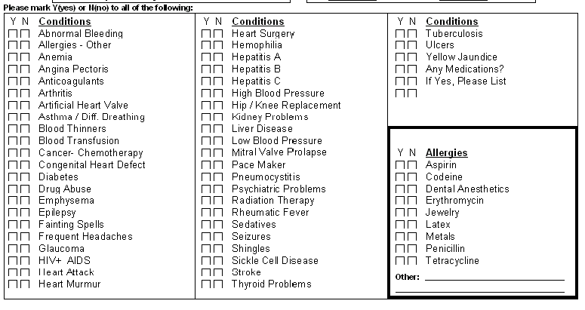

Medications:

Notes / Insurance Breakdown:
Insurance Estimates:
I understand that all insurance coverage is subject to current eligibility. If treatment is recommended, the office staff will estimate my insurance coverage to the best of their ability. I also understand that insurance estimates are not a guarantee of insurance payment. Actual indemnity will be determined at the time my insurance carrier processes the claim. I am responsible for all amounts not covered by dental insurance. If my provider participates with my insurance carrier they will accept fees as stated on the explanation of benefits provided by my insurance carrier and I will be responsible for any co-pays.

Signature: Date:



